Experiment No: 02
Experiment Name: Performing File and Directory Management and Understanding File Permissions in Linux
Theory: Linux file and directory management relies on hierarchical structures and robust permission systems. The mkdir -p command creates nested directory paths recursively, while ls -l displays detailed file information including permissions, and ls -a reveals hidden system files. The cp command duplicates files or directories, tree generates visual hierarchy representations, and man provides comprehensive command documentation. Understanding these tools is essential for efficient system navigation, secure file organization, and permission-aware administration in multi-user Linux environments.
Commands and Output:
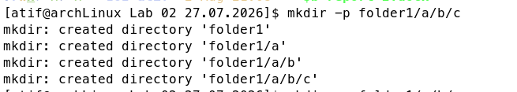
- mkdir -p folder1/a/b/c
Creates nested directories recursively, building parent directories as needed.

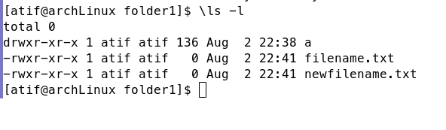
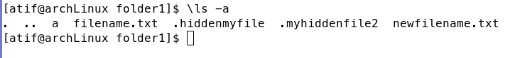
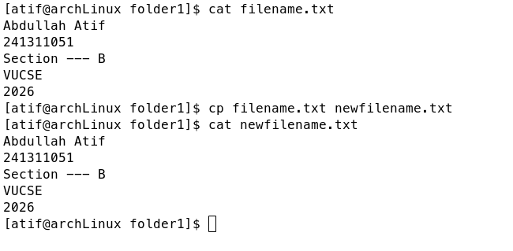
- ls -l
Lists files in long format showing permissions, ownership, size, and modification date.
- ls -a
Lists all files including hidden files that start with a dot (.)
- cp
Copies files or directories from a source to a destination.

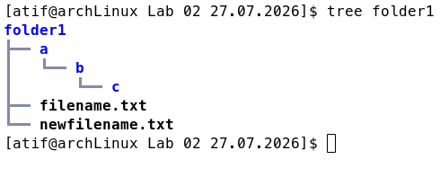
- tree
Displays directory structure in a tree-like visual format.

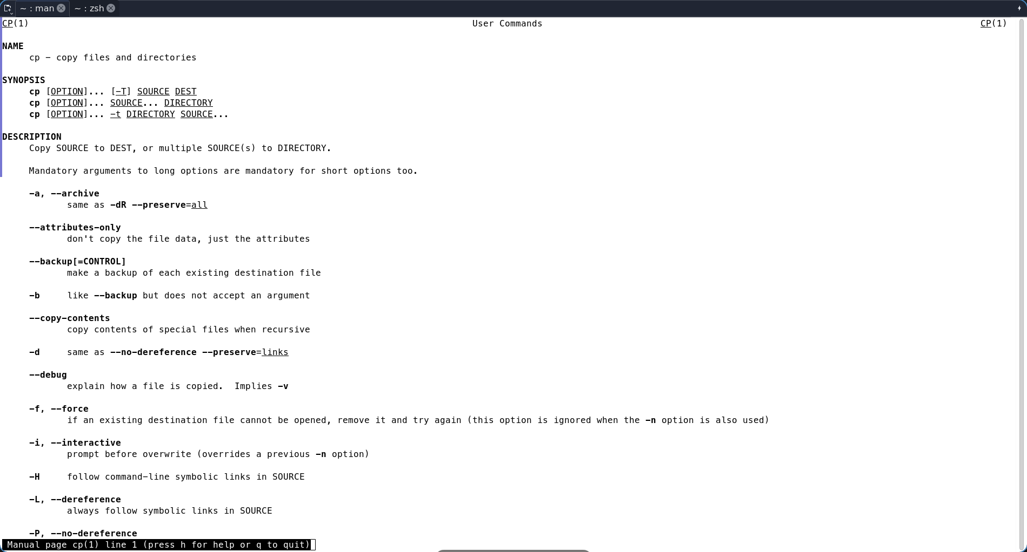
- man
Opens the manual page for a specified command to view documentation.

Discussion: This experiment explored advanced file management and permission concepts in Linux. Using mkdir -p, we created nested directory structures efficiently, while ls -l and ls -a provided insights into file metadata and hidden contents. The cp command enabled file duplication, tree offered visual hierarchy clarity, and man served as a critical reference tool. These commands collectively streamline system administration. In conclusion, mastering these utilities enhances our ability to manage files securely and navigate Linux environments effectively.

